LAB EXPERIMENT - 12

Step 2 Connect both the machine

Create and run ansible playbook

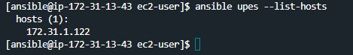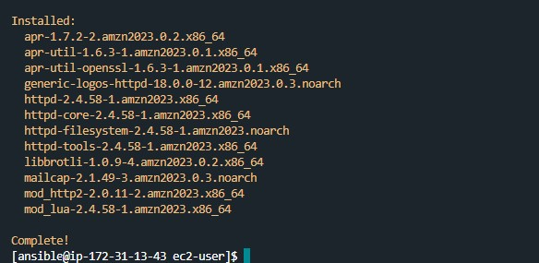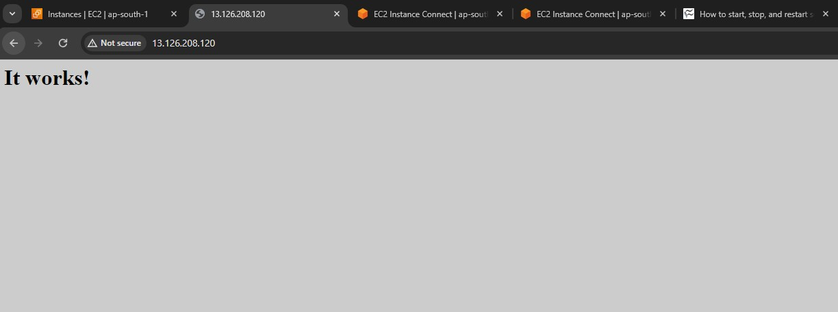

Doing the same via ansible playbook

